<https://communityforums.atmeta.com/t5/Get-Help/Running-the-Unity-Editor-Playback-on-Virtual-Desktop/td-p/763173>

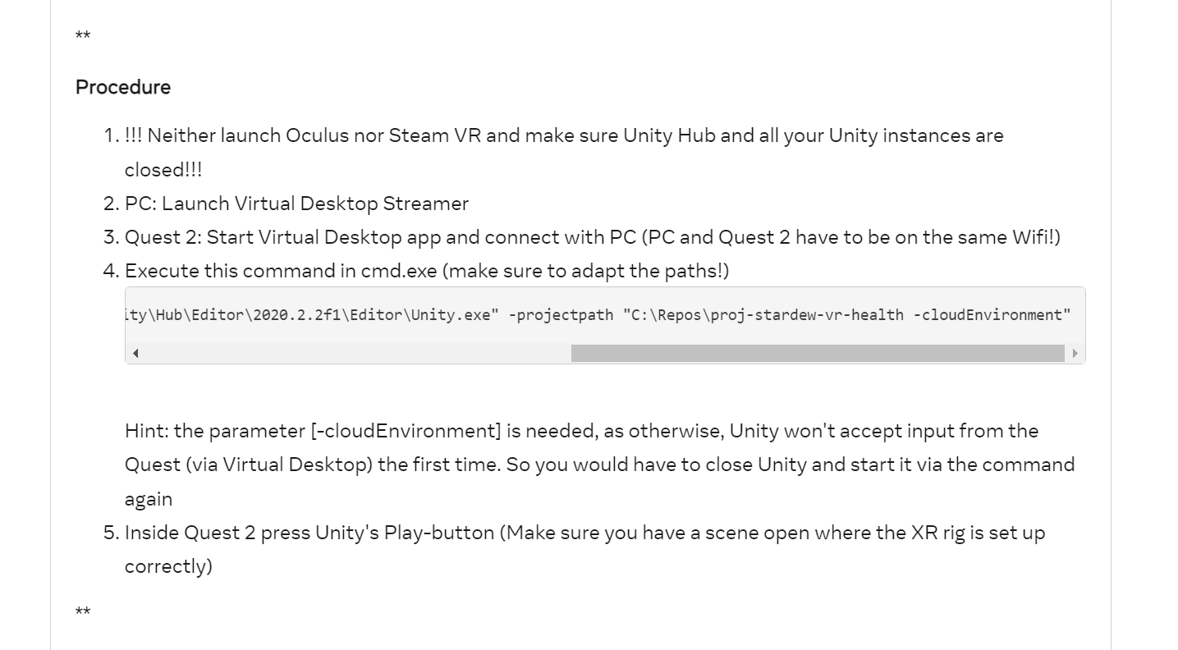

"C:\Program Files\Virtual Desktop Streamer\VirtualDesktop.Streamer.exe" "C:\Program Files\Unity\Hub\Editor\2020.2.2f1\Editor\Unity.exe" -projectpath "C:\Repos\proj-stardew-vr-health -cloudEnvironment"